**ACTIVITY 8**

**NAME : M.Varshini COURSE : Mobile Computing Reg No : 192421293 COURSE CODE: ITA0302**

8. Create an infographic in Figma explaining the concept of Public Land Mobile Network

(PLMN).

**Aim**:

To create an infographic in Figma explaining the concept of Public Land Mobile Network

(PLMN).

**Procedure:**

1. Open Figma

2. Create a new file

3. Select the Frames

4. Fill in the content that is required for presentation

5. Design Visual Elements

6. Make it Interactive

7. Add Annotations and Explanations

8. Incorporate Multimedia

9. Storyboard Animation

10. Review and edit the Prototype

11. Save and Share

**Design:**

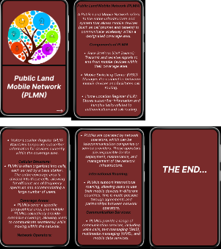

**Prototype:**

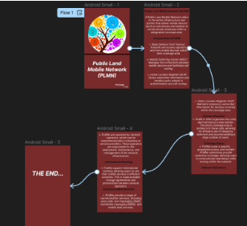

**Result:**

Hence created an infographic in Figma explaining the concept of Public Land Mobile Network

(PLMN).